Weekly Lab Assignment- 1  
Lab Scenario - GIT & GITHUB  
1. Create a Git Repo on the local,

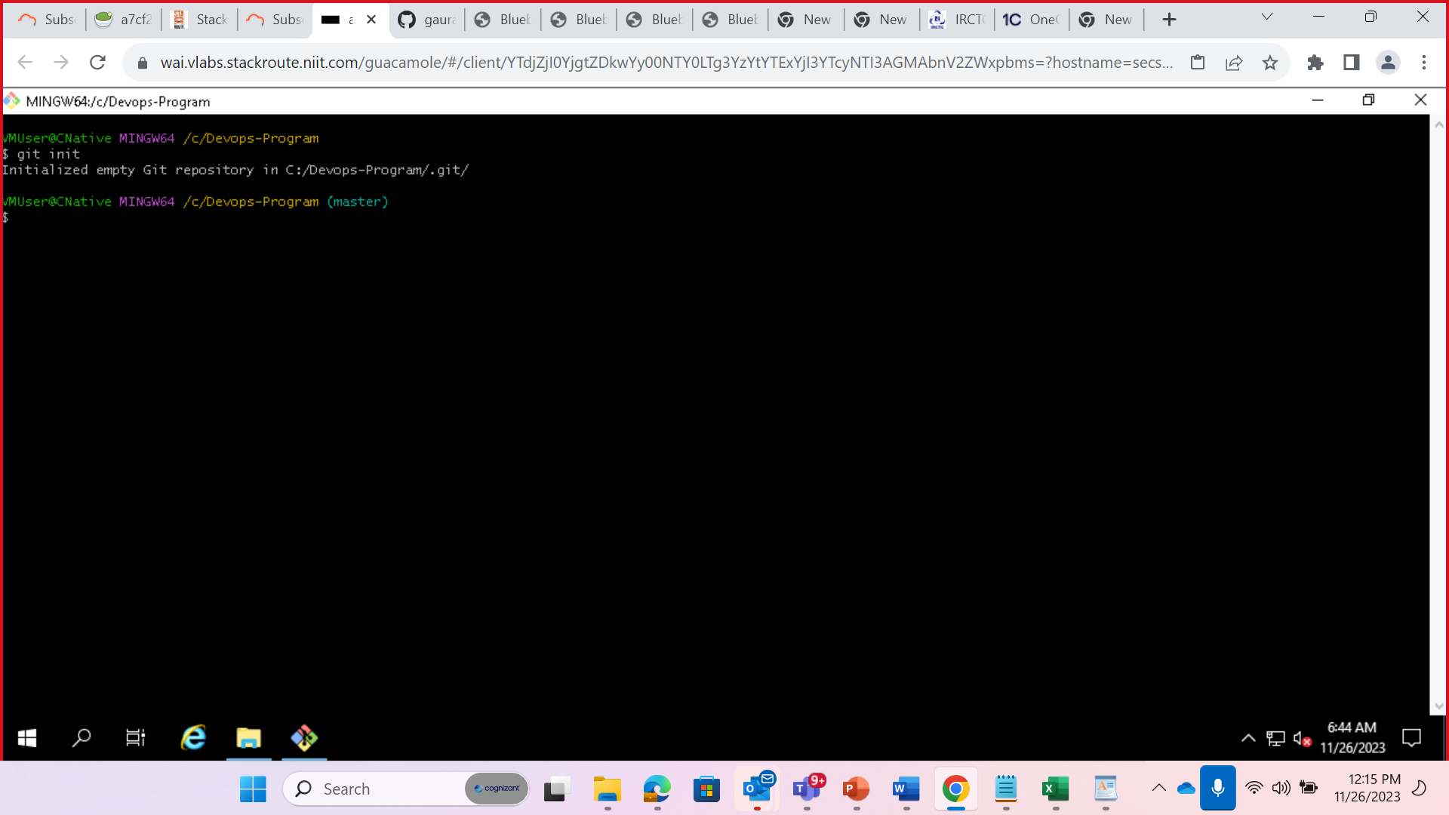  
2. Create a file with "Add" 1st line in the file" in the Local Master and commit it

3. Push it to GITHUB.com

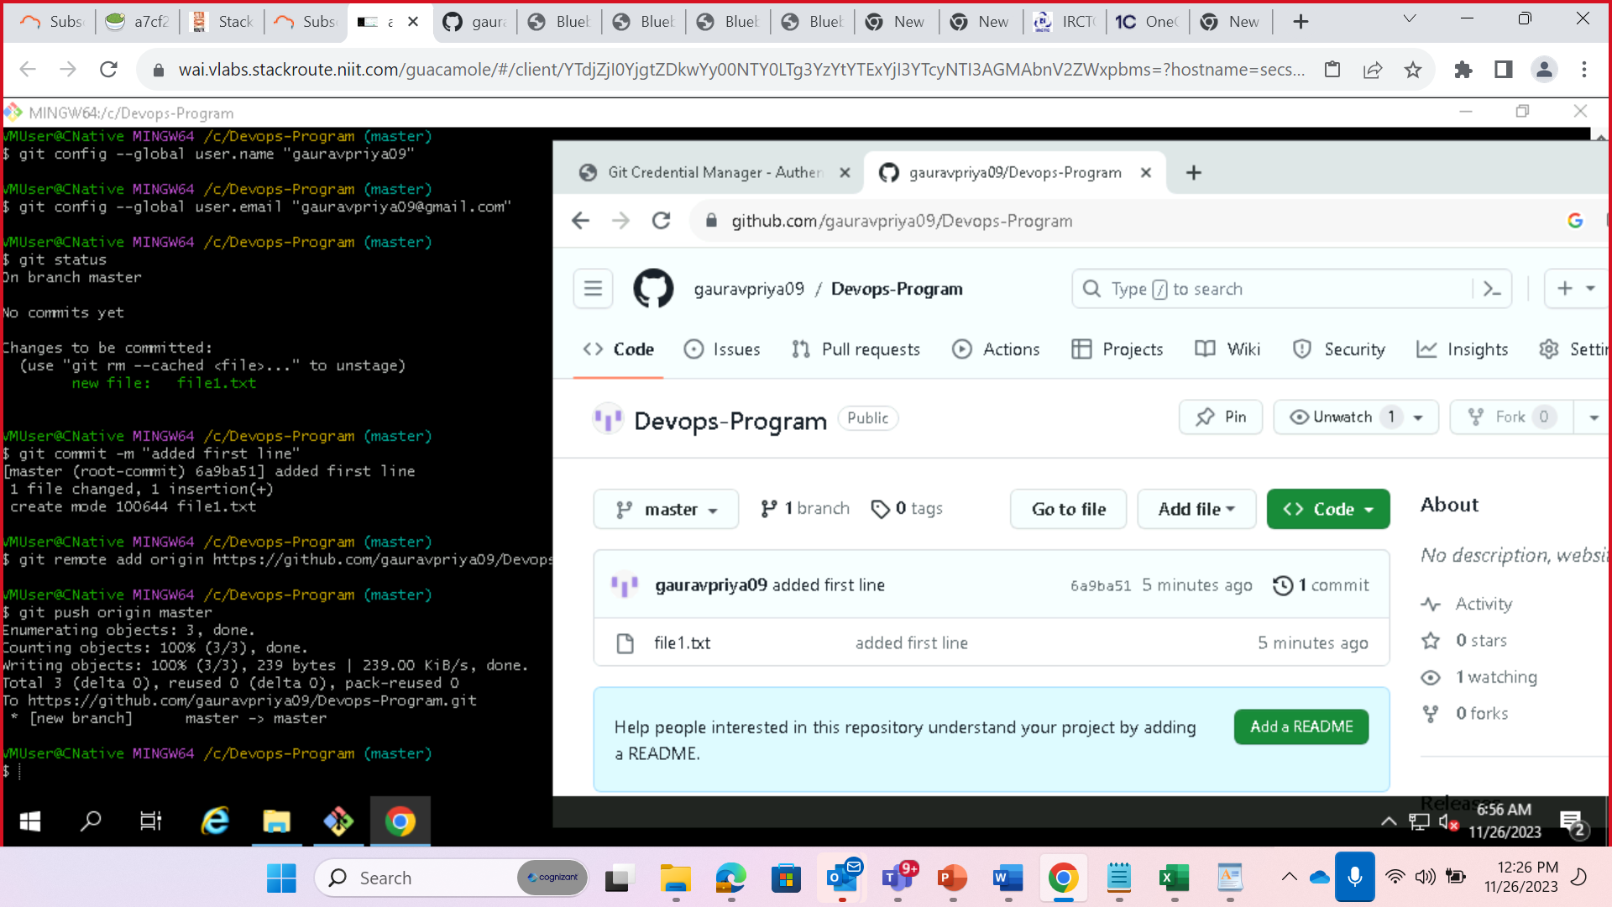  
4. Add" 2nd line in the file on the Git HUB master and Commit it

5. Pull it on the local repo

6. Create a Branch for the file in the GITHUB

7. Pull It on the local repo

8. Add the 3rd line in the file on the Local Master.

9. Add the 5th line in the file on the Local Branch

10. Push the Local Branch to the GitHUB

11. Merge the Branch to the Master on the GiTHUB

